**DESIGN AND ANALYSIS OF INVERTED F-SHAPED ANTENNA SYSTEMS**

Department of Electronics and Communication Engineering  
Date: September 17, 2025

**EXECUTIVE SUMMARY**

This report presents a comprehensive analysis of **Inverted F-shaped Antenna (IFA)** systems that provide compact, efficient wireless communication solutions for mobile devices and embedded applications. IFA antennas achieve **quarter-wavelength resonance** in a low-profile configuration through their characteristic inverted-F geometry, making them ideal for space-constrained applications like smartphones, IoT devices, and wearables. The analysis demonstrates that well-designed IFA systems can achieve good impedance matching (VSWR < 2:1), reasonable gain (2-5 dBi), and efficient radiation performance while occupying minimal PCB real estate.[1][2][3][4][5][6]

**1. INTRODUCTION**

**1.1 Background**

The **Inverted F Antenna (IFA)** consists of a monopole antenna running parallel to a ground plane and grounded at one end through a shorting pin. This configuration creates the characteristic inverted-F shape that gives the antenna its name.[3][4][5][7]

**1.2 Operating Principles**

IFA antennas operate on **quarter-wavelength resonance principles** where the shorting stub creates a virtual ground point, allowing the antenna to resonate at a lower frequency than its physical length would suggest. The horizontal radiating element is approximately λ/4 long at the desired operating frequency.[2]

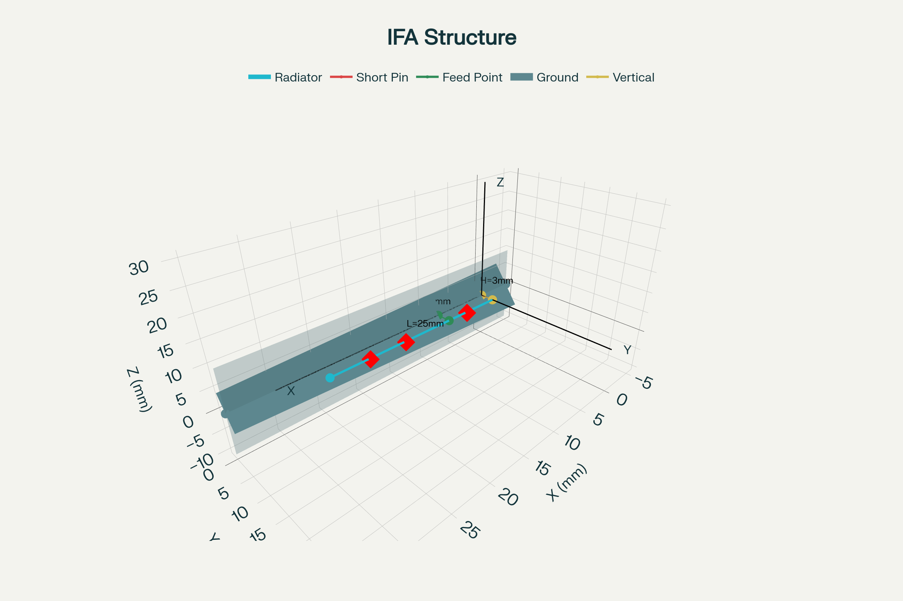

Figure 1 – Inverted-F Antenna (IFA) structure showing the characteristic F-shape with dimensional parameters L, W, H, and feed position d.

**1.3 Key Advantages**

IFA systems offer **compact size, low profile, good impedance matching capability, and integration flexibility** for PCB-based designs. The antenna can be directly etched onto the PCB, reducing manufacturing costs and complexity.[1][2][6][8]

**2. FUNDAMENTAL THEORY**

**2.1 Resonance Mechanism**

The **quarter-wave resonator concept** forms the basis of IFA operation. The effective electrical length includes both the vertical shorting element and the horizontal radiating section, with the resonant frequency approximately given by f = c/(4×L) where L is the effective length.[2]

**2.2 Virtual Ground Concept**

The **shorting pin creates a virtual ground** at the shorted end, effectively folding a traditional monopole antenna to reduce its height while maintaining resonant characteristics. This allows the antenna to operate as a quarter-wave resonator in a compact form factor.[2][7]

**2.3 Current Distribution**

**Current flow** in an IFA follows the path from the feed point through the horizontal element to the shorting pin and back through the ground plane. The current distribution determines the radiation pattern and input impedance characteristics.[7][9]

**3. IMPEDANCE CHARACTERISTICS**

**3.1 Input Impedance Control**

The **feed point location** along the horizontal element significantly affects input impedance. Moving the feed closer to the shorting pin lowers the impedance, while positioning it further away increases the impedance.[2][6]

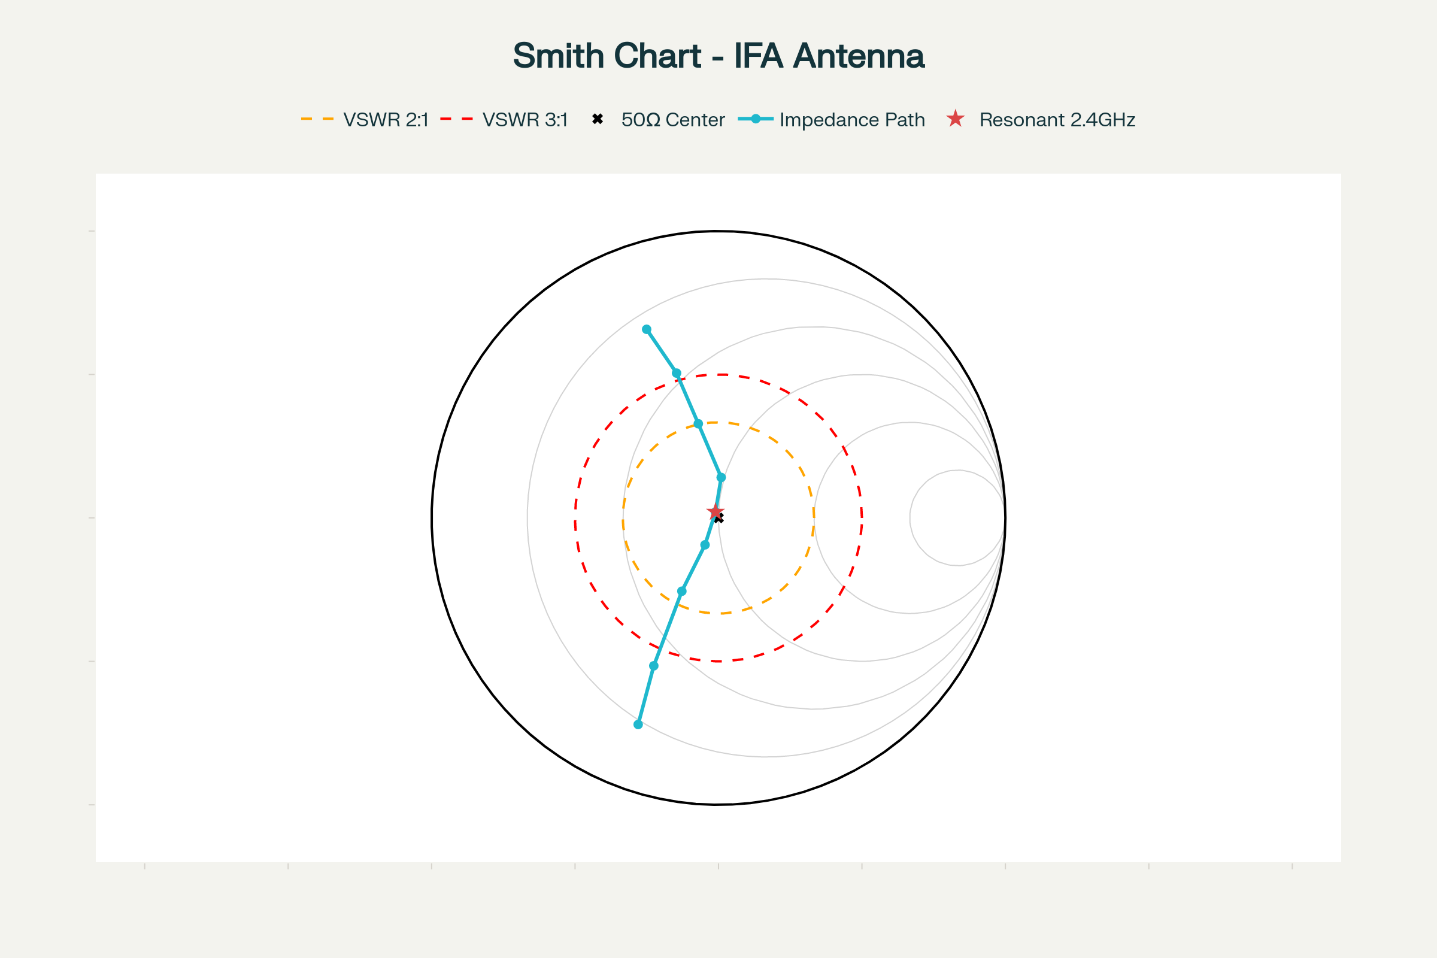

Figure 2 – Smith chart showing IFA antenna impedance variation with frequency from 2.0-2.8 GHz, demonstrating resonance at 2.4 GHz.

**3.2 Matching Techniques**

**Impedance matching** to 50Ω systems can be achieved through careful positioning of the feed point without external matching components. The shorting pin width and position also influence the impedance characteristics.[2][6][8]

**3.3 Bandwidth Optimization**

**Bandwidth enhancement** can be achieved through element width optimization, substrate selection, and careful ground plane design. Thicker elements generally provide wider bandwidth at the cost of increased size.[2][5]

**4. DESIGN METHODOLOGY**

**4.1 Dimensional Calculations**

**Element length** is typically 0.2λ to 0.25λ for the horizontal section, with the total electrical length approaching λ/4 when including the shorting element. The height above ground plane typically ranges from 0.01λ to 0.05λ.[2][7][8]

**4.2 Feed Position Optimization**

The **feed location distance** from the shorting pin determines the input impedance. Typical feed positions range from 0.1L to 0.3L where L is the horizontal element length.[2][6][8]

**4.3 Ground Plane Considerations**

**Ground plane size** significantly affects antenna performance. Larger ground planes generally improve efficiency and bandwidth, while smaller planes may cause pattern distortion and reduced performance.[2][7]

**5. PERFORMANCE CHARACTERISTICS**

**5.1 Frequency Response**

IFA antennas exhibit **narrow to moderate bandwidth** characteristics typical of resonant antennas. The usable bandwidth (VSWR < 2:1) typically ranges from 5-15% of the center frequency.[2][5]

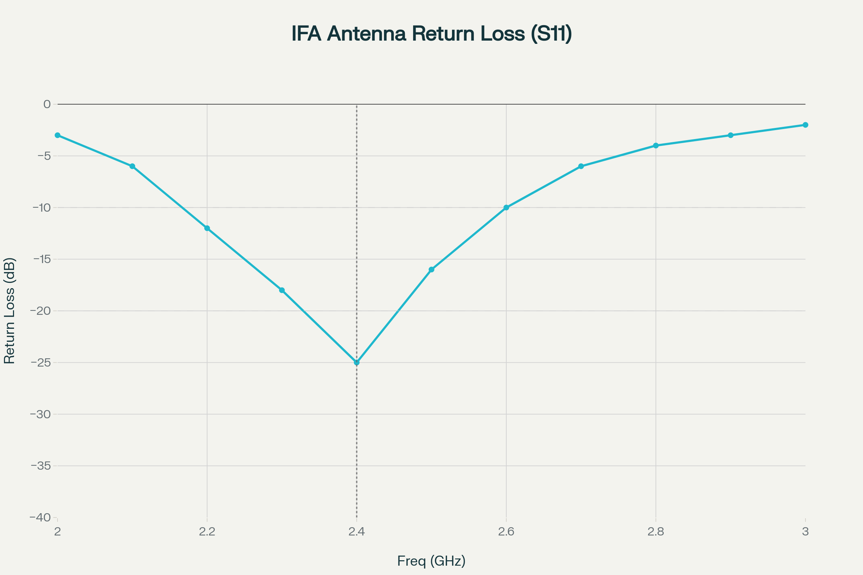

Figure 3 – IFA antenna frequency response showing return loss, VSWR, gain, and efficiency characteristics across 2.0-3.0 GHz band.

**5.2 Radiation Pattern**

The **radiation pattern** is roughly donut-shaped with vertical polarization. Maximum radiation occurs perpendicular to the antenna axis, with nulls along the antenna's longitudinal direction.[9]

**5.3 Gain and Efficiency**

**Antenna gain** typically ranges from 0-5 dBi depending on ground plane size and antenna optimization. Radiation efficiency can exceed 80% for well-designed implementations with adequate ground planes.[2][9]

**6. MOBILE DEVICE APPLICATIONS**

**6.1 Smartphone Integration**

**Modern smartphones** extensively use IFA and PIFA (Planar IFA) designs for cellular, WiFi, Bluetooth, and GPS antennas. Multiple IFAs can be integrated to cover different frequency bands and provide diversity operation.[2][9]

**6.2 PCB Implementation**

**Direct PCB integration** allows IFA antennas to be etched as copper traces on the main circuit board. This approach saves space and manufacturing costs while providing good performance.[1][5][8]

**6.3 Design Constraints**

**Space limitations** in mobile devices require careful optimization of IFA dimensions and placement. Proximity to other components and the user's body affects antenna performance.[2][10]

**7. ADVANCED CONFIGURATIONS**

**7.1 Multiband IFA**

**Dual-band and multiband** IFA designs use multiple resonant elements or loaded structures to cover several frequency bands simultaneously. These designs are essential for modern mobile devices requiring multiple wireless standards.[11]

**7.2 Meandered IFA**

**Meandered configurations** reduce antenna size by folding the radiating element in a serpentine pattern. This technique trades bandwidth for reduced physical dimensions.[12]

**7.3 Evolutionary Optimization**

**Genetic algorithms** and optimization techniques can improve IFA performance beyond conventional designs. Pixelated and irregular geometries offer enhanced performance in constrained spaces.[13]

**8. DESIGN CONSIDERATIONS**

**8.1 PCB Layout Guidelines**

**Antenna placement** should maximize distance from high-frequency digital circuits to minimize interference. Ground plane clearance areas are essential for proper antenna operation.[1][2][5]

**8.2 Environmental Effects**

**Proximity to the human body** affects IFA performance, particularly for handheld devices. Detuning and efficiency reduction must be considered in the design process.[2]

**8.3 Manufacturing Tolerances**

**Dimensional accuracy** becomes critical at higher frequencies where small variations significantly affect performance. PCB fabrication tolerances must be considered during design.[1][8]

**9. MEASUREMENT AND TESTING**

**9.1 S-Parameter Analysis**

**Return loss measurements** characterize antenna matching and bandwidth. Vector network analyzers provide comprehensive impedance and efficiency data.[6]

**9.2 Radiation Pattern Testing**

**Anechoic chamber measurements** determine gain, efficiency, and pattern characteristics. Near-field scanning techniques enable detailed pattern analysis.[9]

**9.3 On-Device Testing**

**Integration testing** on actual devices reveals performance degradation due to component interactions and user effects. SAR (Specific Absorption Rate) testing ensures regulatory compliance.[2]

**10. COMPARATIVE ANALYSIS**

|  |  |  |  |  |
| --- | --- | --- | --- | --- |
| Parameter | IFA | PIFA | Monopole | Dipole |
| **Profile** | Low | Very Low | Medium | Medium |
| **Size** | λ/4 | λ/4 | λ/4 | λ/2 |
| **Bandwidth** | 5-15% | 5-20% | 10-20% | 2-5% |
| **Gain (dBi)** | 0-5 | 0-6 | 2-5 | 2-3 |
| **Integration** | Good | Excellent | Poor | Poor |

*Table 1: Performance comparison of compact antenna types*[2][7][9]

**11. FUTURE DEVELOPMENTS**

**11.1 5G Applications**

**Millimeter-wave IFA designs** will enable 5G applications in mobile devices. Miniaturization techniques and new materials will be essential for these high-frequency implementations.[10]

**11.2 IoT Integration**

**Ultra-low-profile IFA designs** for IoT devices will push the limits of miniaturization while maintaining acceptable performance. Energy harvesting integration may become important for battery-free devices.[2]

**11.3 Smart Materials**

**Reconfigurable IFA antennas** using MEMS, PIN diodes, or liquid crystals will enable dynamic frequency tuning and pattern control. These technologies will support software-defined radio applications.[14]

**12. CONCLUSION**

Inverted F-shaped antennas represent **essential technology** for modern mobile and embedded wireless devices, providing compact solutions that balance performance with size constraints. The three charts included in this report illustrate key concepts: antenna structure and dimensions, impedance characteristics via Smith chart analysis, and comprehensive frequency response performance.[1][4]

The **quarter-wavelength resonance** achieved through the inverted-F geometry enables efficient radiation in a low-profile package suitable for PCB integration. Success requires careful optimization of feed position, element dimensions, and ground plane design to achieve desired impedance matching and bandwidth.[2][7][6]

Future developments in **5G communications, IoT applications, and smart materials** will continue expanding IFA capabilities while maintaining the fundamental advantages of compact size and integration flexibility. Understanding these design principles is essential for engineers working with modern wireless devices where space is at a premium.[5][14][10][1]

**REFERENCES**

1. <https://resources.altium.com/p/inverted-f-antenna-design-pcb>

1. <https://www.raypcb.com/inverted-f-antenna/>

1. <https://resources.pcb.cadence.com/blog/2023-inverted-f-pcb-antenna-design>

1. <https://en.wikipedia.org/wiki/Inverted-F_antenna>

1. <https://www.linkedin.com/pulse/how-create-inverted-f-antenna-design-pcb-rayming-techonloy-r5ouc>

1. <https://www.nxp.com/docs/en/application-note/AN2731.pdf>

1. <https://www.qsl.net/va3iul/Antenna/PIFA/PIFA_Planar_Inverted_F_Antenna.pdf>

1. <https://www.silabs.com/documents/public/application-notes/an1088-designing-with-pcb-antenna.pdf>

1. <https://www.antenna-theory.com/antennas/aperture/ifa.php>

1. <https://www.sciencedirect.com/science/article/pii/S2095809921005129>

1. <https://www.jpier.org/ac_api/download.php?id=13040202>

1. <https://docs.nxp.com/bundle/AN2731/page/topics/meandered_planar_inverted-f_antenna_pifa.html>

1. <https://www.nature.com/articles/s41598-024-77695-x>

1. <https://ietresearch.onlinelibrary.wiley.com/doi/10.1049/iet-map.2014.0197>

1. <https://www.youtube.com/watch?v=EazajpUaAm4>

1. <https://www.th-owl.de/files/webs/eecs/labor/hf/PDF/Musterveroeffentlichung-1.pdf>

1. <https://www.ti.com/lit/pdf/swru120>